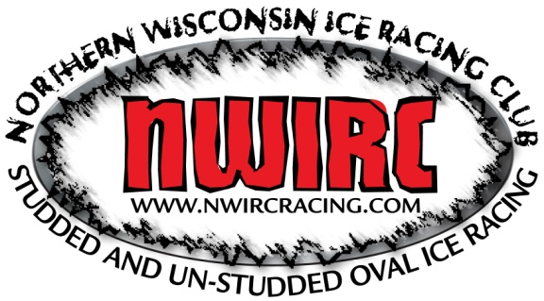
2018 NWIRC Membership
Name: ______________________________________________
Race #:_____________________
Race Classes: __________________________________________________________________
Address: ______________________________________________________________________
Telephone Number: ____________________________________
E-Mail Address: ________________________________________
Jacket size:____________________________

2018 NWIRC Membership
Name: ______________________________________________
Race #:_________________
Race Classes: __________________________________________________________________
Address: ______________________________________________________________________
Telephone Number: ____________________________________
E-Mail Address: ________________________________________
Jacket Size:_______________________________________

